*WhenToWork – Camps Staff Training*

All Hourly Camps Staff Members will be scheduled for regular work shifts using **WhenToWork**, an online scheduling and communication tool. As long as there is a connection to the internet, employees can access WhenToWork anytime, anywhere using a web browser (on a computer or Apple Device), or a downloadable app (on an android device).

Supervisors will create an account for hourly staff members. Once created, the employee will be responsible for updating and maintaining contact information. WhenToWork will send notifications using email and text messages depending on the preferences set by the employee.

Supervisors will create schedules based on the availability of their staff members. After an account has been created, employees will check WhenToWork regularly and use it to:

* View your work schedule
* Communicate with your supervisor and/or co-workers on schedule-related issues
* Request days off
* Check the notice board for important information posted by your supervisor

Staff schedule availability, including any subsequent changes in the ability to work assigned shifts, should be submitted in the manner described by division supervisors. For example, there may be specific guidelines for the amount of advance notice needed when requesting time off. These guidelines may differ between divisions and may change due to scheduling needs around holiday periods. Any questions about these guidelines should be directed to your supervisor.

WhenToWork should generally **not** be used for shift cancellations within 24 hours, especially for those who are assigned to work at Camp Locations. Instead, please speak with your supervisor or someone in the division so that other arrangements can be made to cover the immediate scheduling need.

## Accessing WhenToWork

From a computer or apple device, open a web browser and go to: [www.whentowork.com](http://www.whentowork.com)

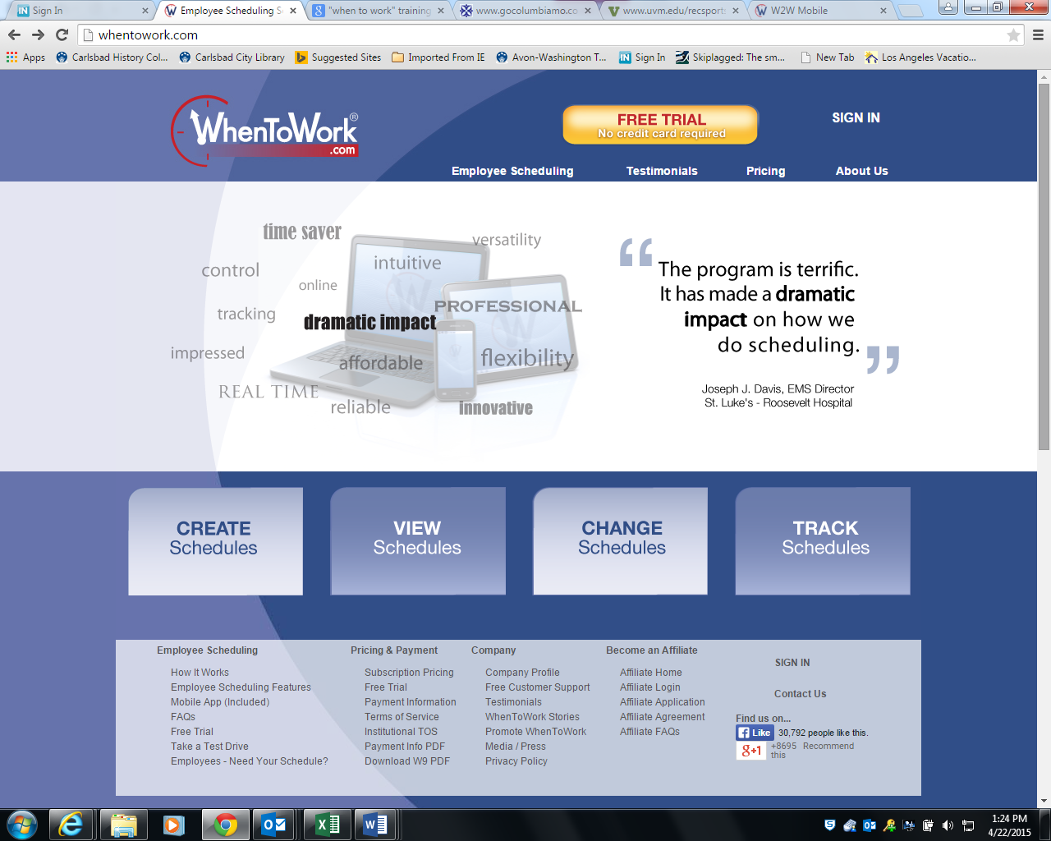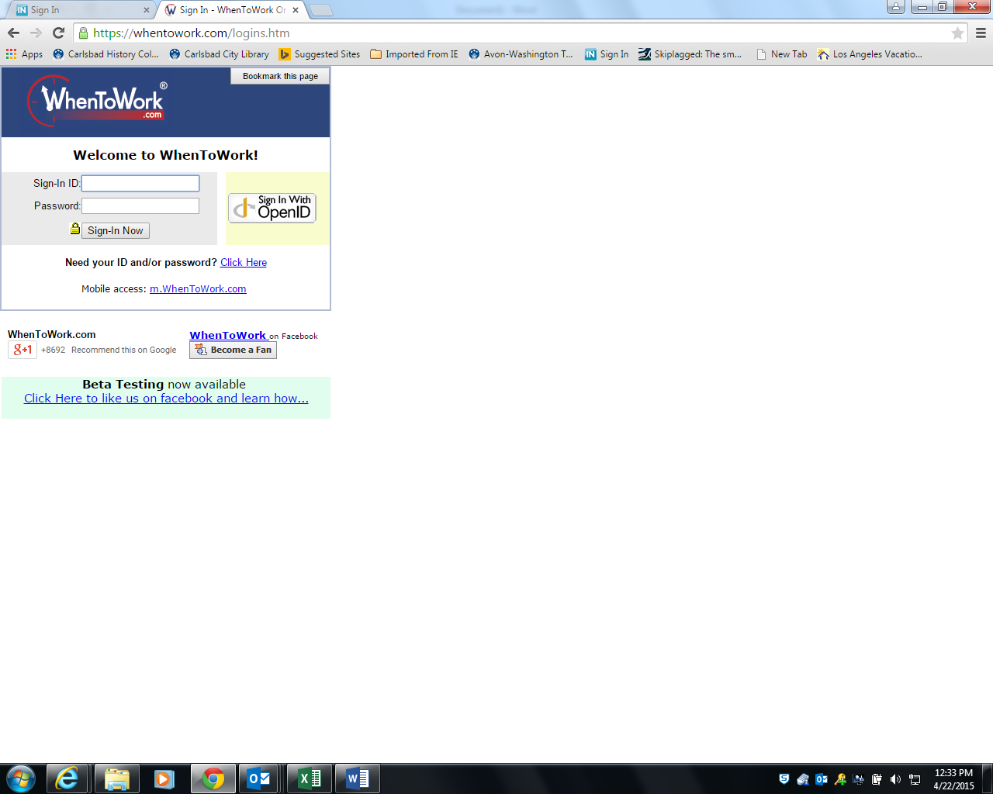

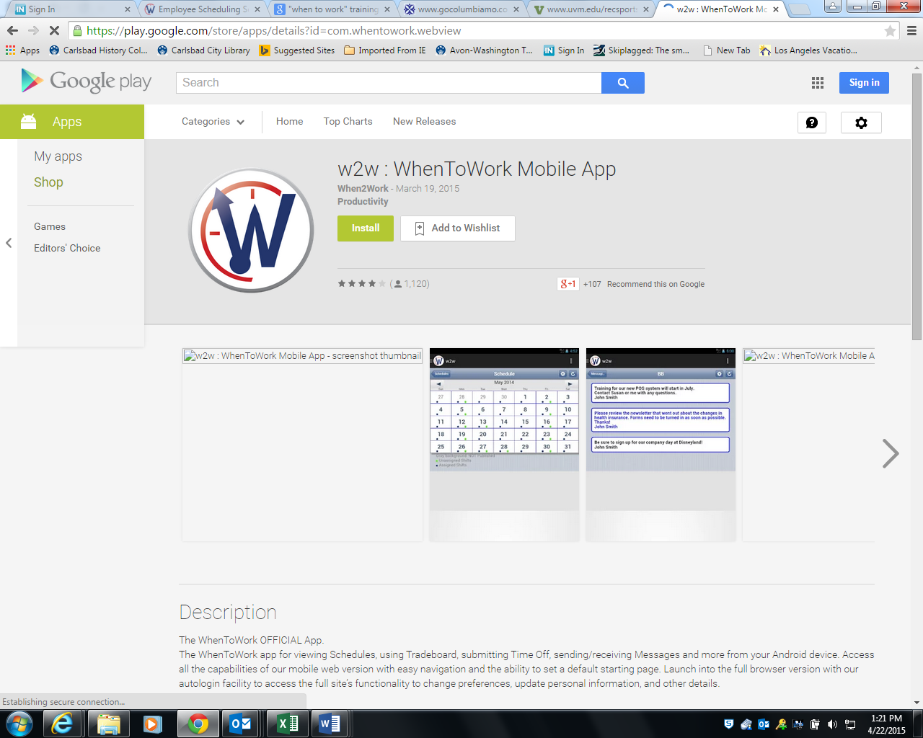

For android devices, go to the play store and install the WhenToWork mobile app:

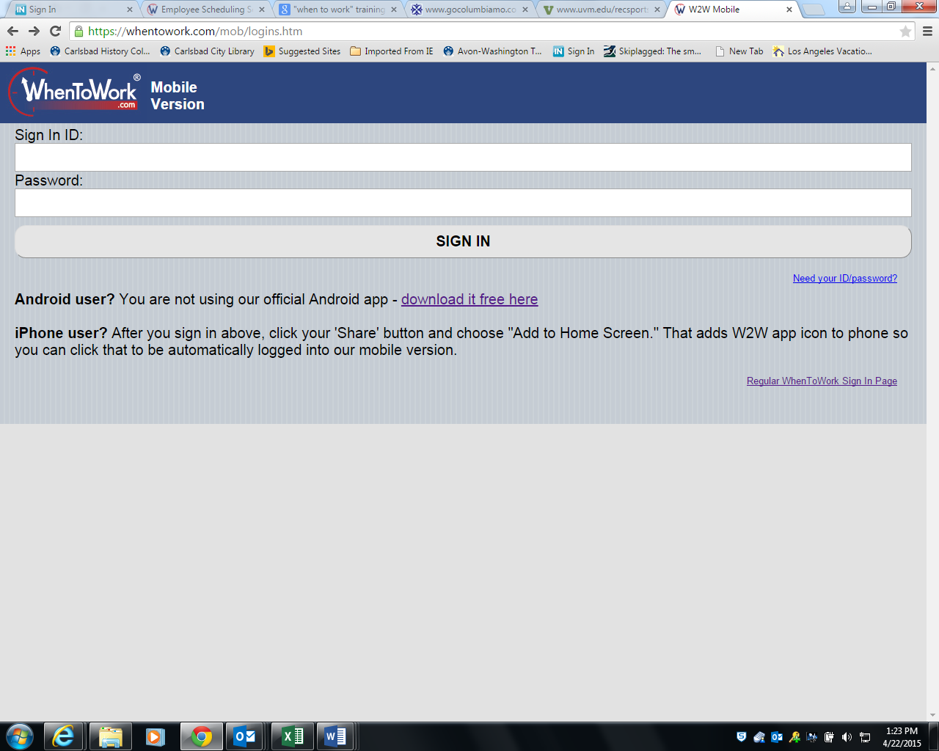

The sign on for the mobile version looks like this:

## Logging into WhenToWork for the First Time

Hourly staff will have an account created by their supervisor. An email will be sent to the employee from WhenToWork that will have first-time login credentials. It is recommended that the WhenToWork instructions email not be deleted until after the id/password has been changed.

**Step 1:** Sign in to WhenToWork using the temporary ID and password that was sent to you in the email. Both will start with W2W.

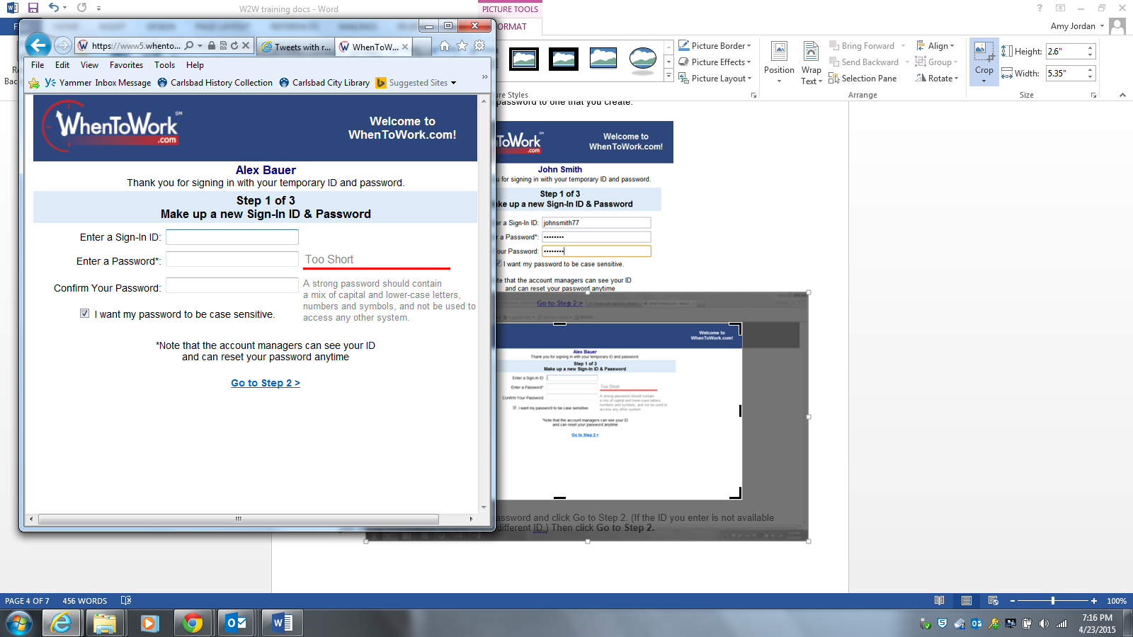

You will be prompted to create a new sign-in ID and password of your choice.

Follow the guidelines for creating a password.

If you do not want the password to be case sensitive, uncheck the box.

*Please note that this password will not be updated when the other scheduled network passwords get changed.*

Click on the *Go to Step 2* link.

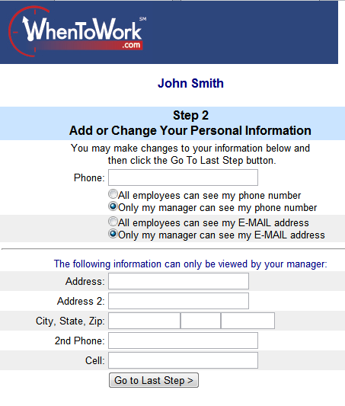

**Step 2:** Your supervisor may have already entered some information for you. Enter any information and settings you want added or changed.  After entering or updating, click on the *Go to Last Step* button.

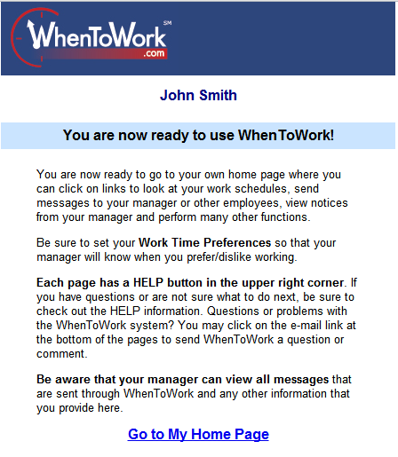

**Step 3**: Click on the *Go to My Home Page* link where you can view schedules and announcements.

## Personal Home Page

After signing in, you will be taken to your personal home page:

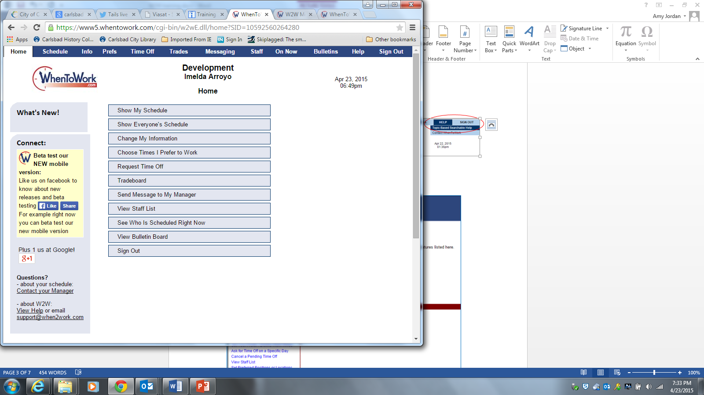

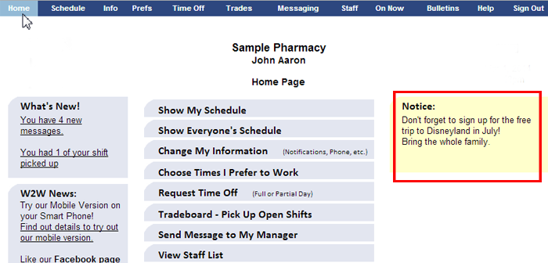

Your WhenToWork employee home page has a section that shows you **What's New** since you last signed in and provides links to the alert notices. You can click on the links to find out more about that alert and go to that section.

If your supervisor has posted an announcement for employees, you will see it as a **Notice** on the right hand side of your personal home page.

You can use the menu links (at the top of your personal home page) or the menu bars to check your schedule, change your contact preferences and information, update your availability, request time off, send messages, and sign out.

## Getting Help with WhenToWork

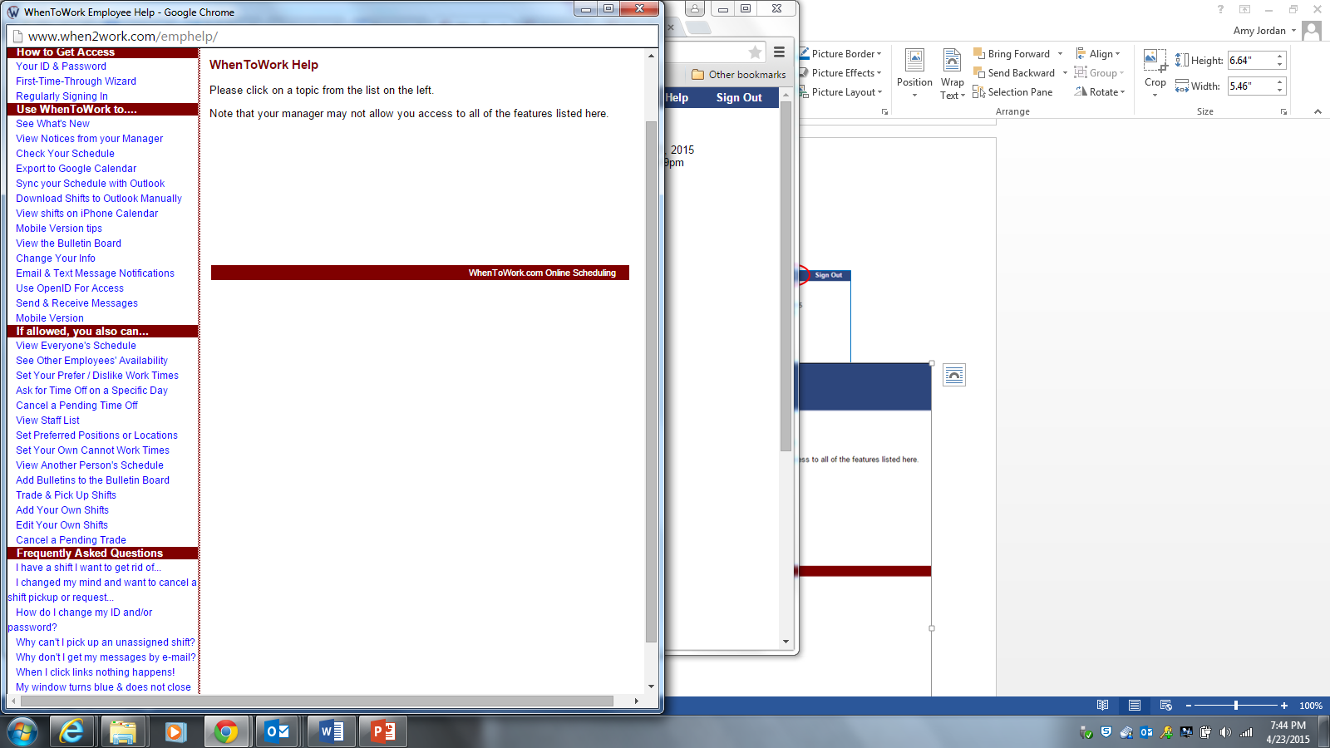Once logged in, help is available on the task bar at the top of the screen:



A new window will open.

Click on any link for more information about that topic.

## Forgotten or Invalid Sign-in ID/Password

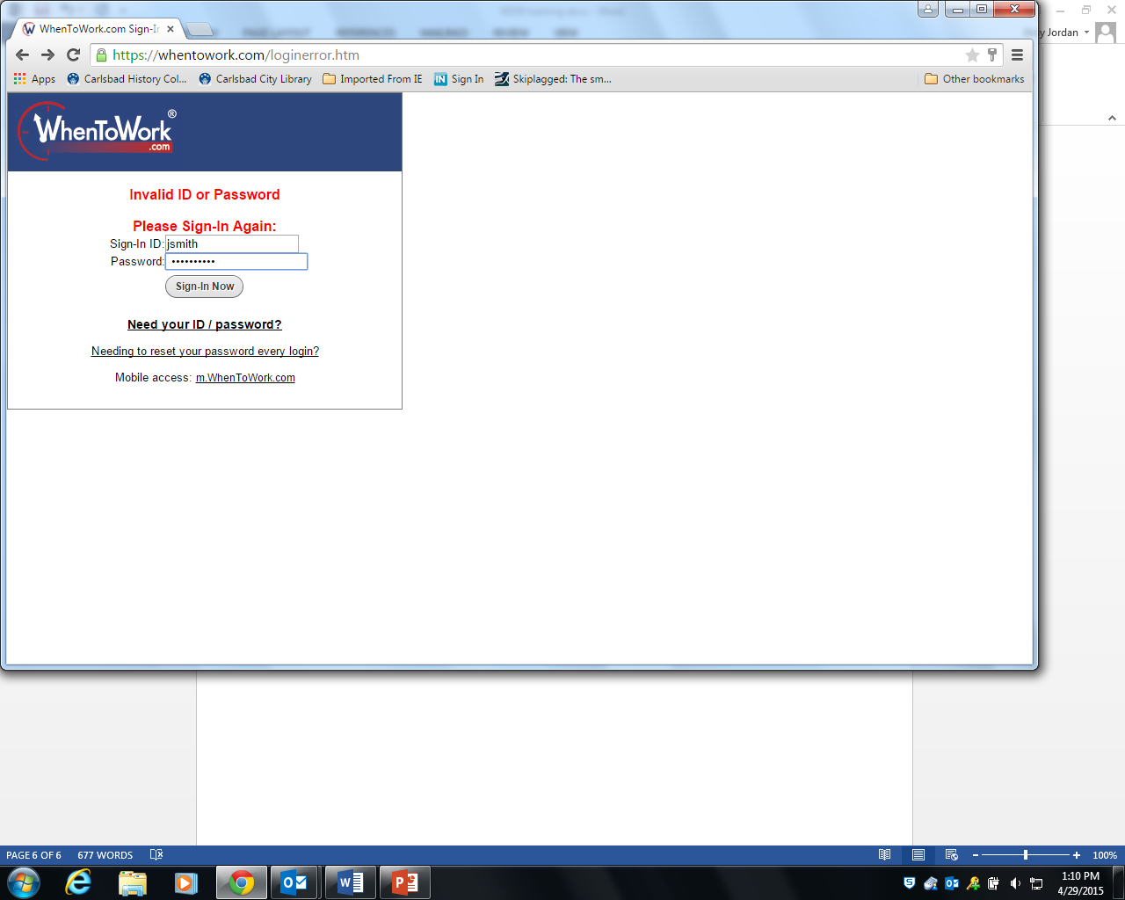If you cannot remember your password, or if you enter an incorrect sign-in or password, an error screen will appear.

Click on the link for *Need your ID/password?*

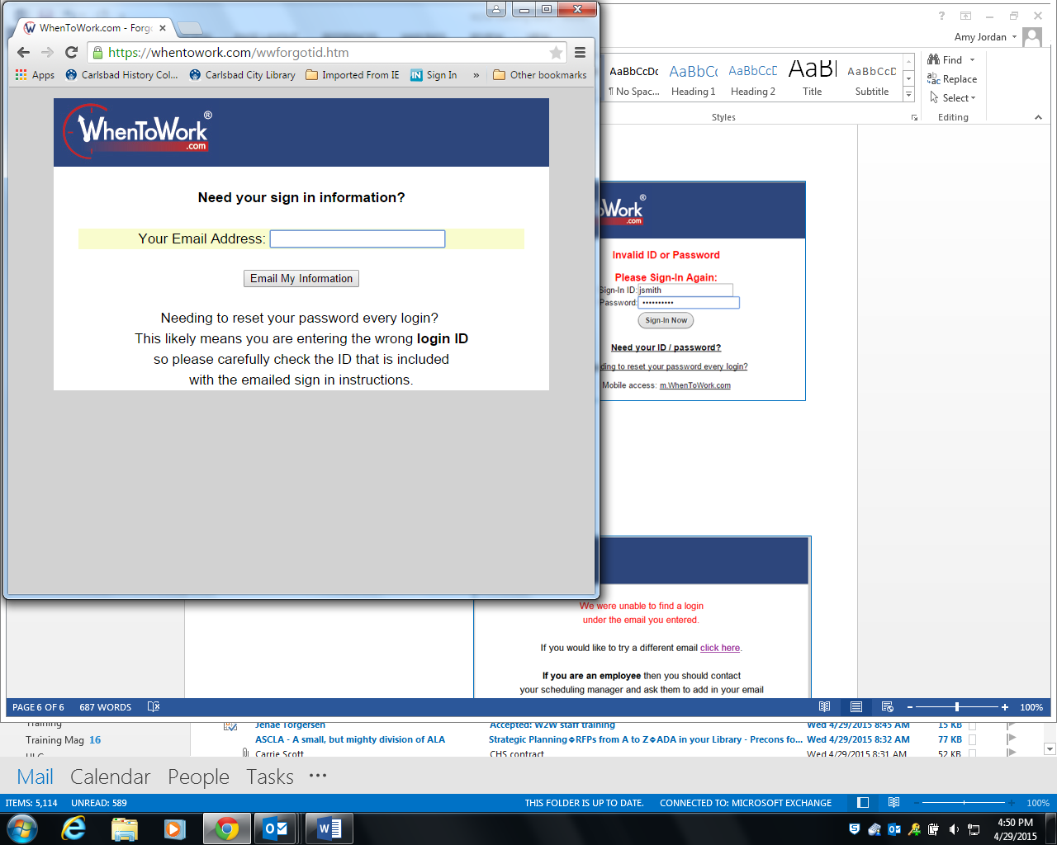

Enter your email address for the account.

Click on *Email My Information*.

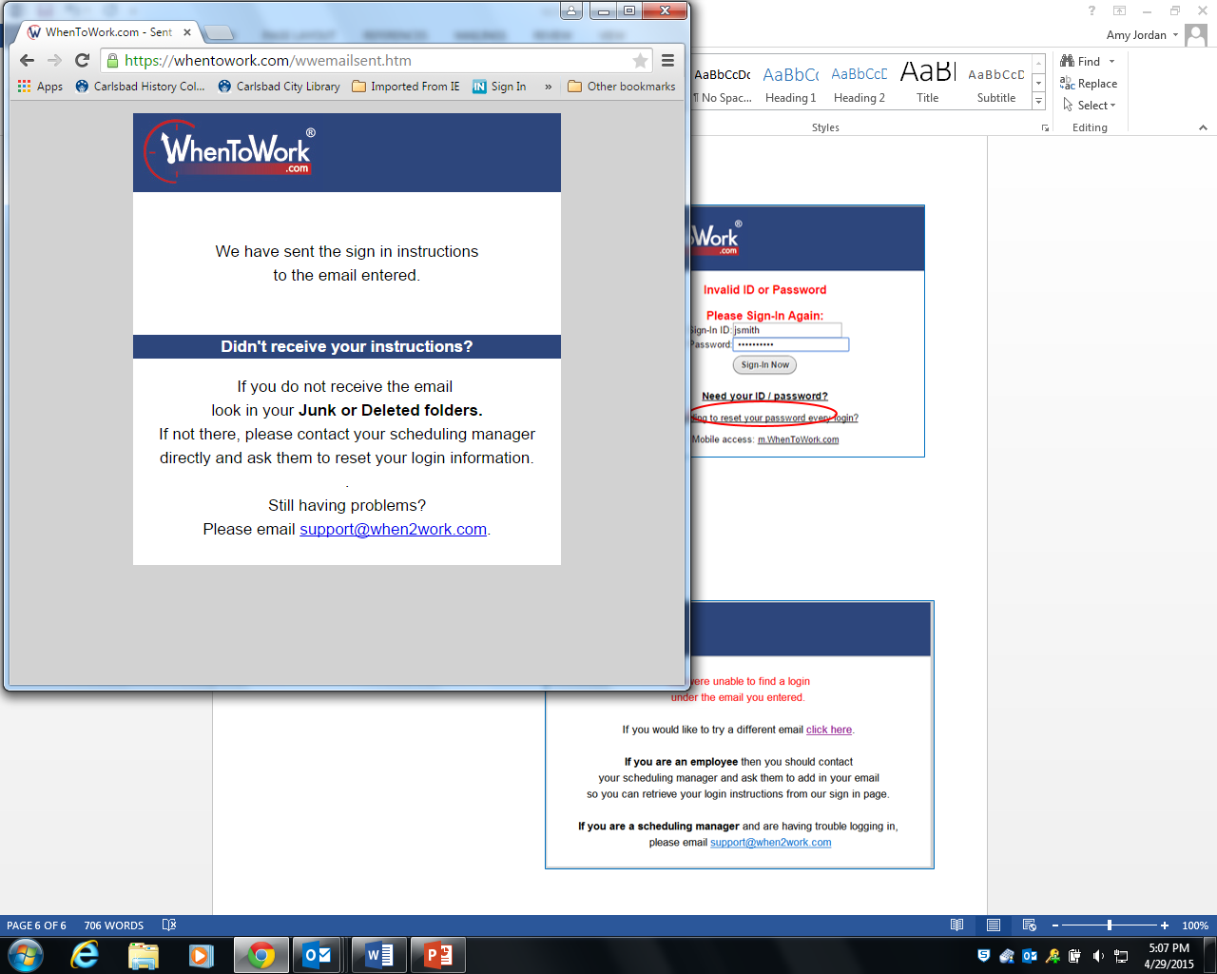If WhenToWork has the address you entered on file, you will receive an email (“*Info You Requested From WhenToWork*”) that contains your sign-in ID and a web link to follow.

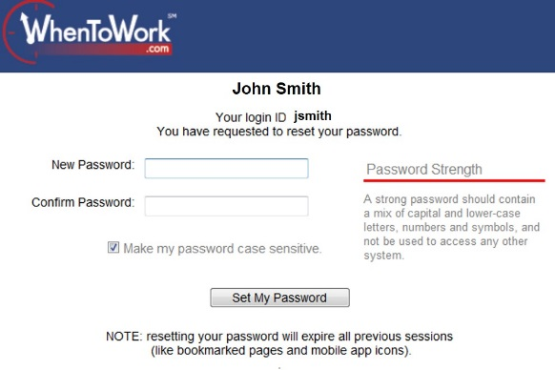

Follow the link from the email so that you can change your password.

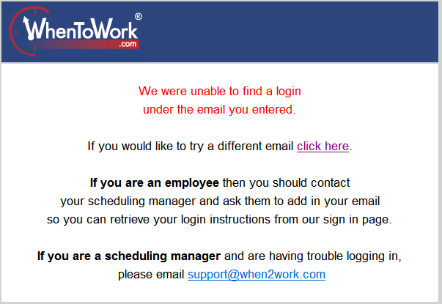

If WhenToWork does **not** have the email address on record, you will get an error message telling you they could not find a record with that email.

You can click on the link to enter a different email address.

If you cannot remember the email you used for the account, or if you need further assistance, **please contact your supervisor**.